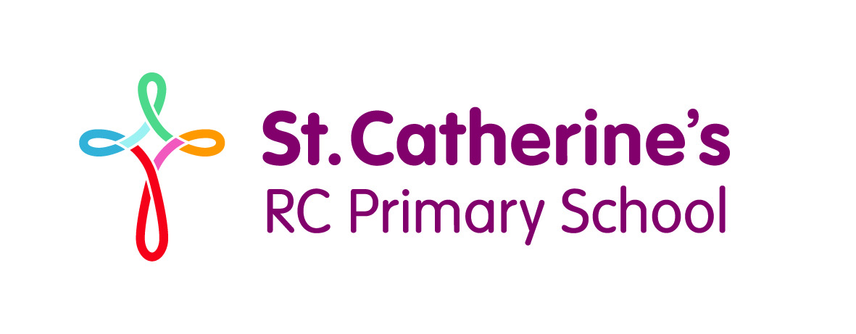
Cursive handwriting made easy!

Dear Parents,
We are reintroducing the Letter-join handwriting scheme in school and any of our pupils wishing to practise their handwriting at home can now log in to the Letter-join website on iPads and tablets as well as desktop and laptop computers. There you will find the same, easy-to-use handwriting resources as we use at school.

How to log in to Letter-join

DESKTOP AND LAPTOP LOG-IN
Simply go to www.letterjoin.co.uk
and log in, using the Desktop log-in boxes, with these details:
User name: ak6685
Password: home

Letter-join will work on the following browsers on PCs:
• Google Chrome • Firefox
• Safari • Opera
We cannot recommend using Internet Explorer for Letter-join.

IPAD AND TABLET LOG-IN
Go to www.letter-join.co.uk, select the Tablet Login button and log in using these details:
User name: ak6685
Swipe code (starting at top left):

Letter-join will run on the following tablets:
• iPads running at least iOS7 through the Safari browser.
• Windows 8 tablets (8 inch and bigger) using the built-in browser.
• Android tablets (8 inch and bigger) using Google Chrome, Firefox or Opera.

Once logged-in, choose your child’s classroom and you will be able to watch how to form all the letters of the alphabet using the same style that we use at school. You can then trace over the letters and words on your tablet and print out the worksheets from your PC for real handwriting practice.

We are limited to the number of users who can log in to this account, so please only log in with this username and password/swipe code for your own personal use.

